***UNIT-II***

***1. Ontology:***

*Ontology is the philosophical study of existence, being, and reality. In other words, ontology is the investigation of the most basic categories of things and how they are related to one another. Additionally, ontology can help us to identify which entities are most fundamental and which ones are present at the most basic level.*

Ontology is sometimes referred to as the *science of being* and belongs to the major branch of philosophy known as [metaphysics](https://en.wikipedia.org/wiki/Metaphysics).

Three main theories about the nature ofreality have developed over the years:

1. Realism
2. Idealism
3. Phenomenology

The **realist vision** corresponds to common sense. Externalreality and the human mind (object and subject) are distinct.External reality is independent from the human mind.If I see a tree, that is because(a) the tree has a real existence, independently from my imagination (b) the image I get from the tree is a faithful copy of the original tree.

It was within a realist vision of the World, supported bythe progress of science and engineerng, that the opposition betweenrationalism and empiricism became one of the mainphilosophical problems of the 17th century.

The **idealist vision** believes that everything of whichwe have a perception is a product of the human mind. Since people only have access to their perceptions, no onecan say that reality corresponds to one’s own perceptions. Our perceptions can mislead us or distortreality (we see the Sun going round Earth,while the contrary is happening). Our senses are limited and do not giveaccess to many dimensions of the real(ultra-violet light is invisible to our eyes)

The **phenomenological approach** asserts that our perception ofthe World, both its tangible and abstract objects (like, e.g., amathematical formula), is built in, and by, our conscience. To understand that constitution process, we mustignore what we know about the World and concentrateon the processes through which knowledge is built. Example: The category “circle” is not a “fact” existing in reality(no perfect circle exists). However, its not just a product of ourmind. We build the notion of circle form the round objects we see.Then, we assign to those objects the ideal form we have created.

***2. Reference Ontology and Application Ontology***

*Ontology can be characterizedinto reference ontology and application ontology. Reference ontologies (foundational ontologies) are rich, axiomatic theories that focus on clarifying the intended meanings of terms used in specific domains.*

*Application ontologies,by contrast, provide a minimal terminological structure to fit the needs of a specific community.Reflecting their minimal nature, there are referredto “lightweight” ontologies. An application ontology can be lightweight in a second respect as well, namely, that it maynot necessarily take the form of fully-fledged axiomatic theory.Rather, it might only be a taxonomyof the relevant domain, a division of the domain into a salient collection of classes, perhaps orderedby the subclass relation. Importantly, though, for an application ontology to “fit the needs of a specific community” needn’t require representational accuracy.*

**2.1 Reference Ontologies**

There appear to be three central characteristics of reference ontologies (ROs). We examine these in turn. Theoretical focus on representation The first characteristic of ROs is their theoretical focus on representation. ROs are constructed without any particular concerns for computational efficiency. Consequently, ROs avail themselves of (at least) the language of full first-order logic. Specifically, ROs avail themselves of:

• Arbitrary n-place predicates;

• Full classical negation;

• Unbounded, arbitrarily nested quantifiers.

The focus of ROs on representation is most clearly indicated in their generally unapologetic use of full first-order languages. The three features above are particularly noteworthy, as unrestricted use of any of them can render complete deductive procedures intractable, even undecidable. The philosophical inclination toward realism The second feature of ROs is their inclination toward philosophical realism.

There are generally two elements of this realism:

• Metaphysical realism;

• Epistemological realism.

According to metaphysical realism, the World (Reality, What There Is) exists objectively in itself, independent of any mind. According to epistemological realism, the World is knowable by us. Thus, the philosophical standpoint underlying most ROs is that the World and its properties are there to be discovered. This implies, in turn, that the World, being objective and knowable, puts constraints on what we can say about it. Thus, in our ontologies can get it wrong. An RO is right just insofar as it accurately reflects, as far as it goes, the way the World is. This leads to our third feature of ROs. Methodological emphasis on Truth Because our ROs can be wrong, there is in the construction of an RO a good reason to place a strong methodological emphasis on Truth.

This has two practical implications:

• The central function of an ontology is to represent the World accurately and comprehensively; hence:

• The quality of an ontology a function of its accuracy and comprehensiveness.

ROs are all about getting the World — or some important piece of it — right.

An ontology of time purports to describe its actual nature, to proffer the sober metaphysical truth on such matters as whether time is discrete, continuous, some combination of the two; whether there are timepoints or intervals, or both, and so on. Consequently, the quality of an ontology is judged along two dimensions: its accuracy — i.e.,

whether what it purports to be the case is in fact the case — and its comprehensiveness — i.e., whether it takes in a sufficiently broad spectrum of facts as to be significant.

**2.2 Application Ontologies**

Corresponding to our three features of reference ontologies are three salient features of application ontologies (AOs).

**2.2.1 Theoretical Focus on Reasoning**

Unlike ROs, AOs are typically designed with some sort of computational application — and hence its attendant expressive limitations — in mind. Consequently, AOs are usually expressed in the language of some computationally tractable sub logic of full firstorder logic (see, e.g., [6]). Such languages typically support:

• Reasoning about classes and “slots” through the use of unary and (limited) binary predicates;

• Conjunction and disjunction, but not negation;

**2.2.2. Philosophical inclination toward pragmatism/ instrumentalism/constructivism**

Unlike the strong realism underlying ROs, for AOs, take a far more pragmatic view of the World, both metaphysically and epistemologically. Specifically, the metaphysical presumption underlying a typical AO is the falsity, or at least the irrelevance, of metaphysical realism. The objects and structures we encounter in the World — those parts of it that matter to ontology, anyway — are social constructs, products of the evolving interaction between conscious, intelligent human agents and, at best, a substrate of unknowable.

The corresponding epistemological presumption is that, even if metaphysical realism is true and there is an ultimate metaphysical reality to the World, that underlying reality probably unknowable anyway. Hence, what we can be said to know is simply what works.

**2.2.3. Methodological emphasis on fidelity**

Methodologically, the central emphasis of an AO must be on fidelity, i.e., to be a faithful expression of the concepts/intuitions of relevant domain experts or sources. All that matters to an AO is how relevant domain experts conceptualize a given domain. The question of any sort correspondence between that conception and an objective external world is idle philosophical speculation with no bearing on the quality of the ontology, which is determined entirely by the extent of its fidelity.

On the face of it, these two approaches two ontology are profoundly different. However, the starkest differences are philosophical; indeed, those differences are probably irreconcilable. However, important as those differences might be conceptually, at the end of the day what we are engaged in is knowledge engineering. And as engineers, I suggest the following tendentious (not to say controversial) thesis: the only components of the two approaches that ultimately matter are the theoretical and methodological. These, I will argue are compatible, indeed complementary. wide-scope universal quantifiers only)



Ontological Layers

**2.3. Reference ontology with regard toapplication ontology**

Application ontologies contain all the definitions thatare needed to model the knowledge required for aparticular application. They are not reusable themselves.

“Application ontologies describe concepts dependingboth on a particular domain and task, which are oftenspecializations of both the related ontologies. Theseconcepts often correspond to roles played by domainentities while performing a certain activity, likereplaceable unit or spare component “.

Reference ontology versus Application ontology

|  |  |
| --- | --- |
| **Reference Ontology** | **Application Ontology** |
| theoretical focus on representing | theoretical focus on representing |
| establishes consensus about meaning of terms | offers terminological services for semantic access, checking constraints between terms |
| maximal coverage | provides a minimal terminological structure |
| Fits the needs of a large community | fits the needs of a specific community |
| Fits the needs of a large community | lightweight ontologies |
| Can’t be derived from application ontology | can be derived from Reference ontology |
| broad and deep | broad and deep |
| designed according to strict ontological principles | designed according to the viewpoint of an end-user in a particular domain |

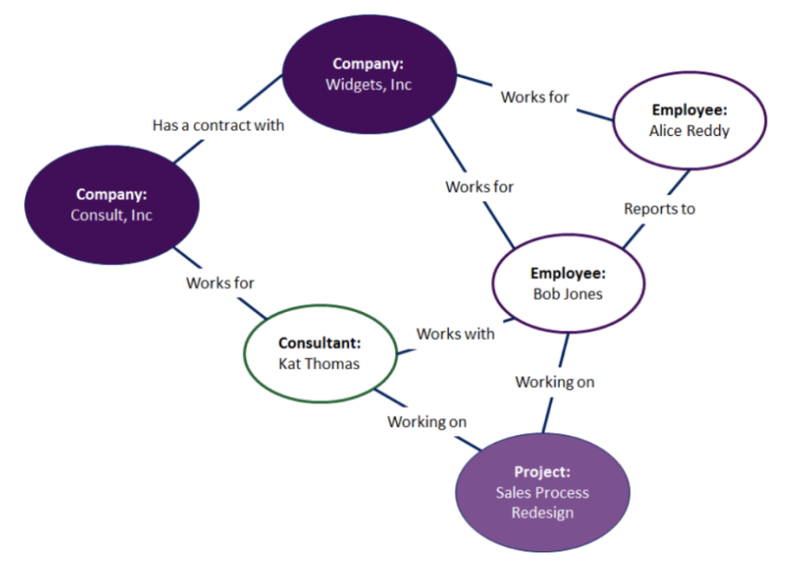

**Ontology example**

1. **Mind Mapping**

A mind map is a tool for the brain that captures the thinking that goes on inside your head. Mind mapping helps you think, collect knowledge, remember and create ideas. Most likely it will make you a better thinker.

Mind maps can be created in many different ways, but they share the same basics:

**3.1 Central theme**

A central theme is placed in the centre of a blank page. This is the title, the subject, a problem or just a thought. When thinking of something images automatically take form in your head. For example the image of a “colorful bunch of balloons” when thinking of “birthday”.

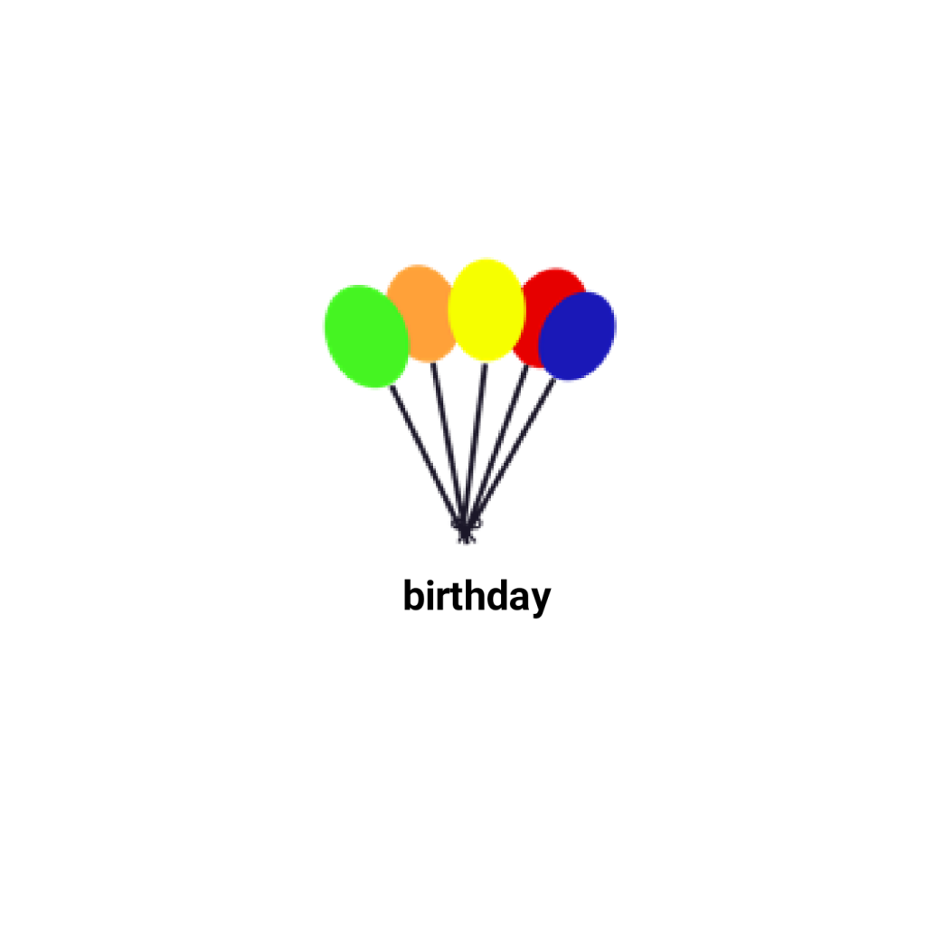

*Fig.1 Central theme & image*

**3.2 Associations**

From the central theme associations radiate out. Associations directly from the central theme are called first level associations. Then second level associations are created, third level and so on. The brain thinks by imagination and association. When associations are created, connections are made. These connections are essential for remembering and thinking.

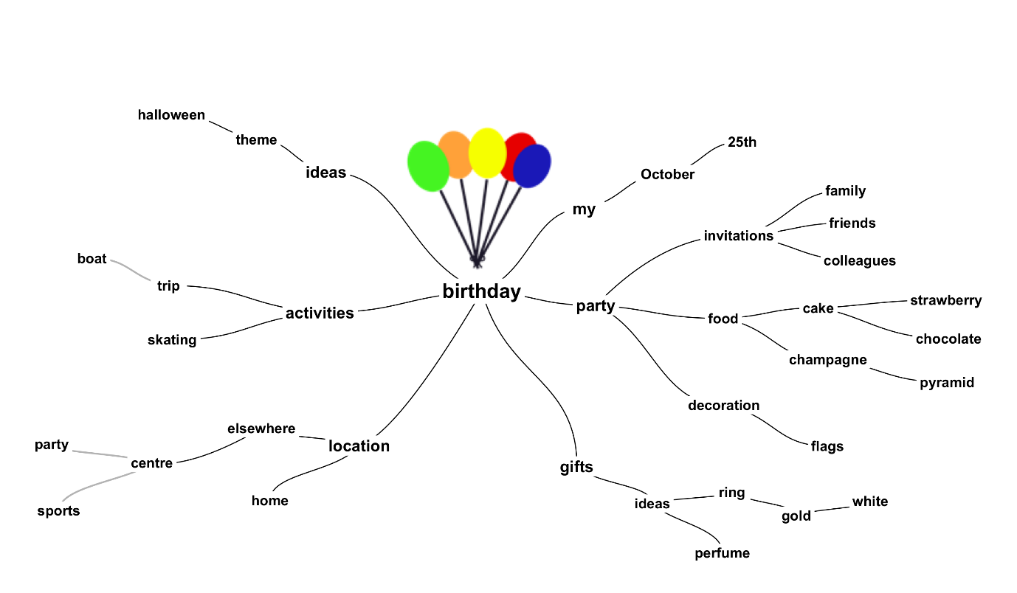

*Fig.2 Central theme & associations*

* 1. **Curved lines**

Associations are often drawn as curved lines. They are  curved rather than straight, because the brain likes curves.

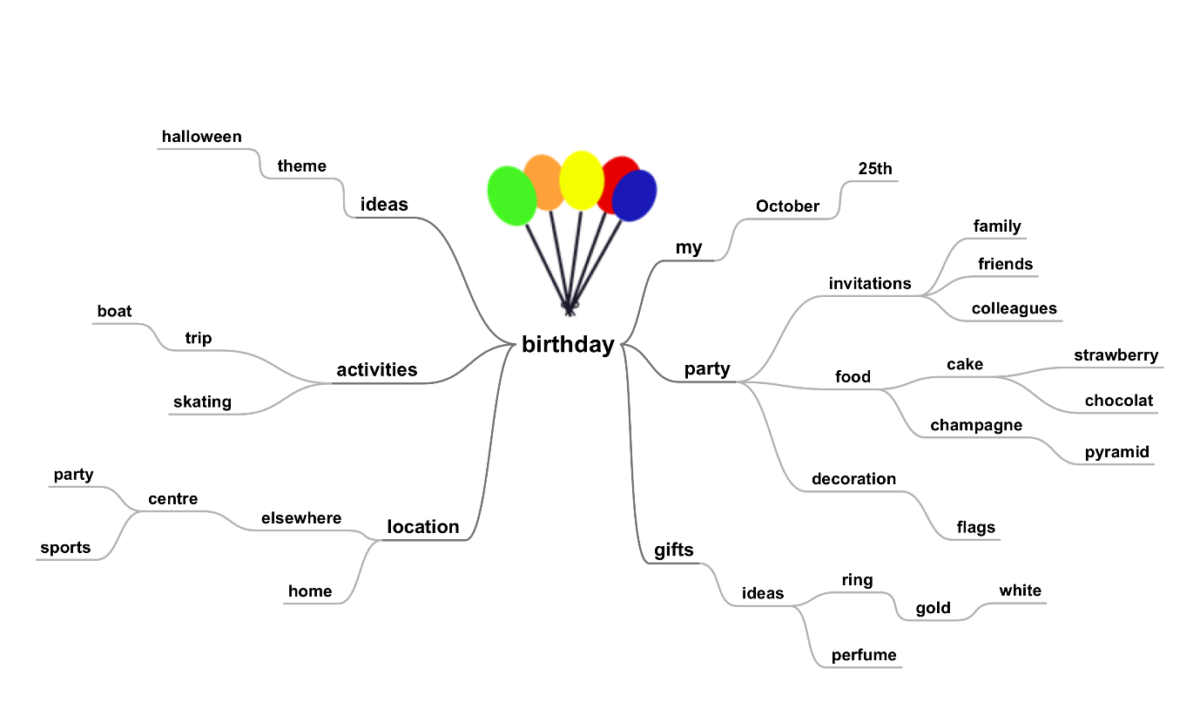

*Fig.3 Curved lines guide the eyes smoothly from one association to the next*

* 1. **Keywords**

Mind maps summarize information. Instead of sentences, ideally only single keywords are used. A single word per association gives more freedom, creativity and clarity.

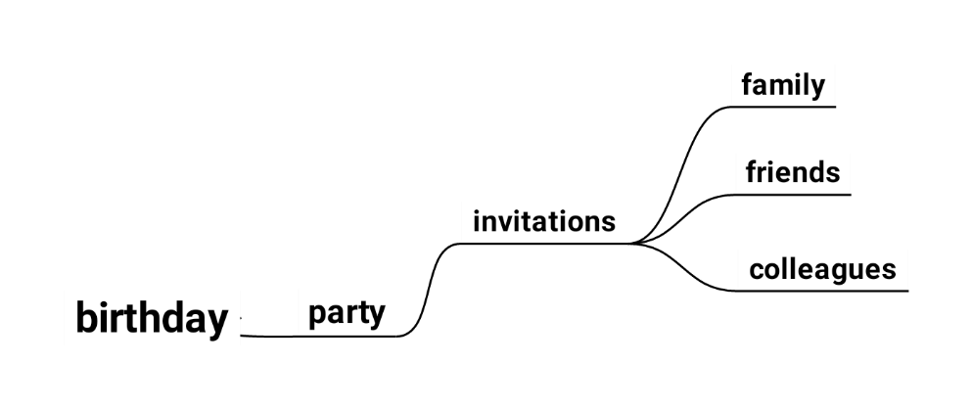

*Fig.4 Keywords summarise and give clarity*

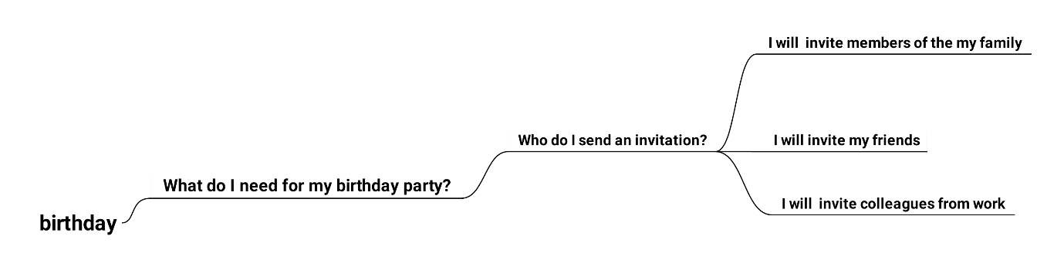

*Fig 5. Sentences are difficult to read and only a very limited number of associations can be made*

* 1. **Proximity**

The length of a word ideally matches the length of a curved line. That causes associated words to  be in close proximity.

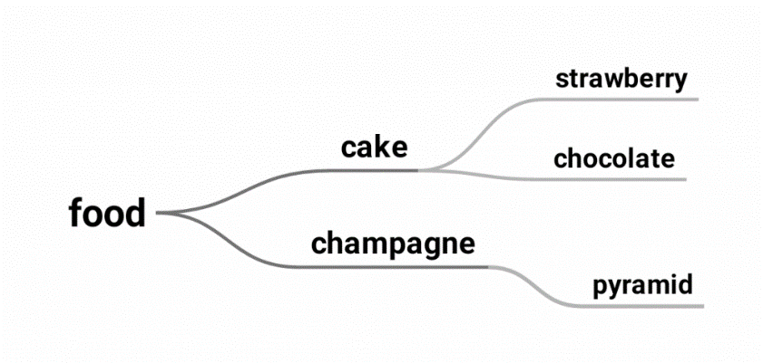

*Fig.6 Words that are close are connected*

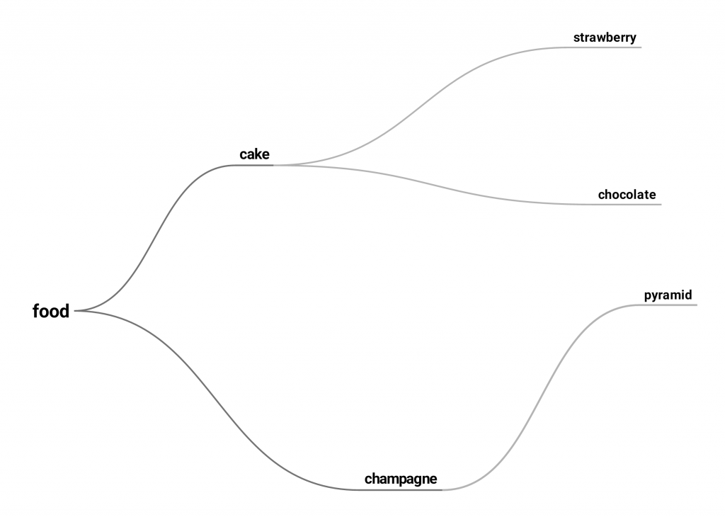

*Fig 7. Words that are far apart are disconnected*

* 1. **Associations**

A mind map can have many first level associations, but the mind can only grasp about a maximum of 7.

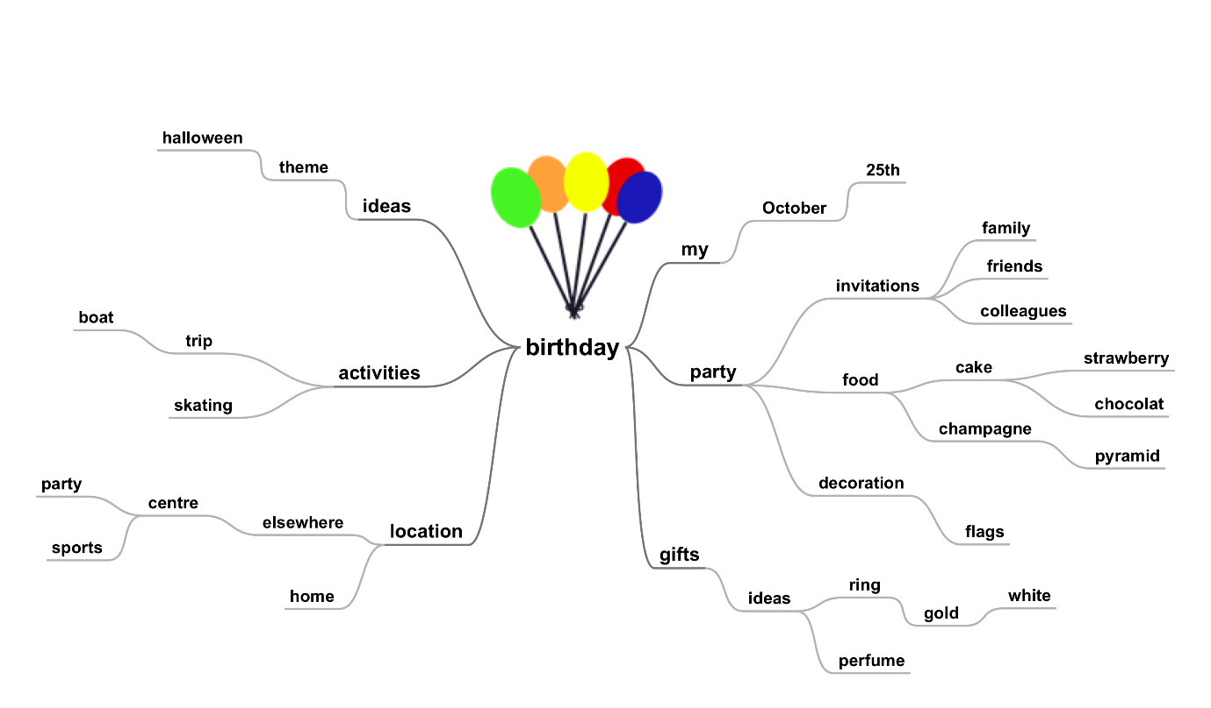

*Fig.8 A few associations give a clear view*

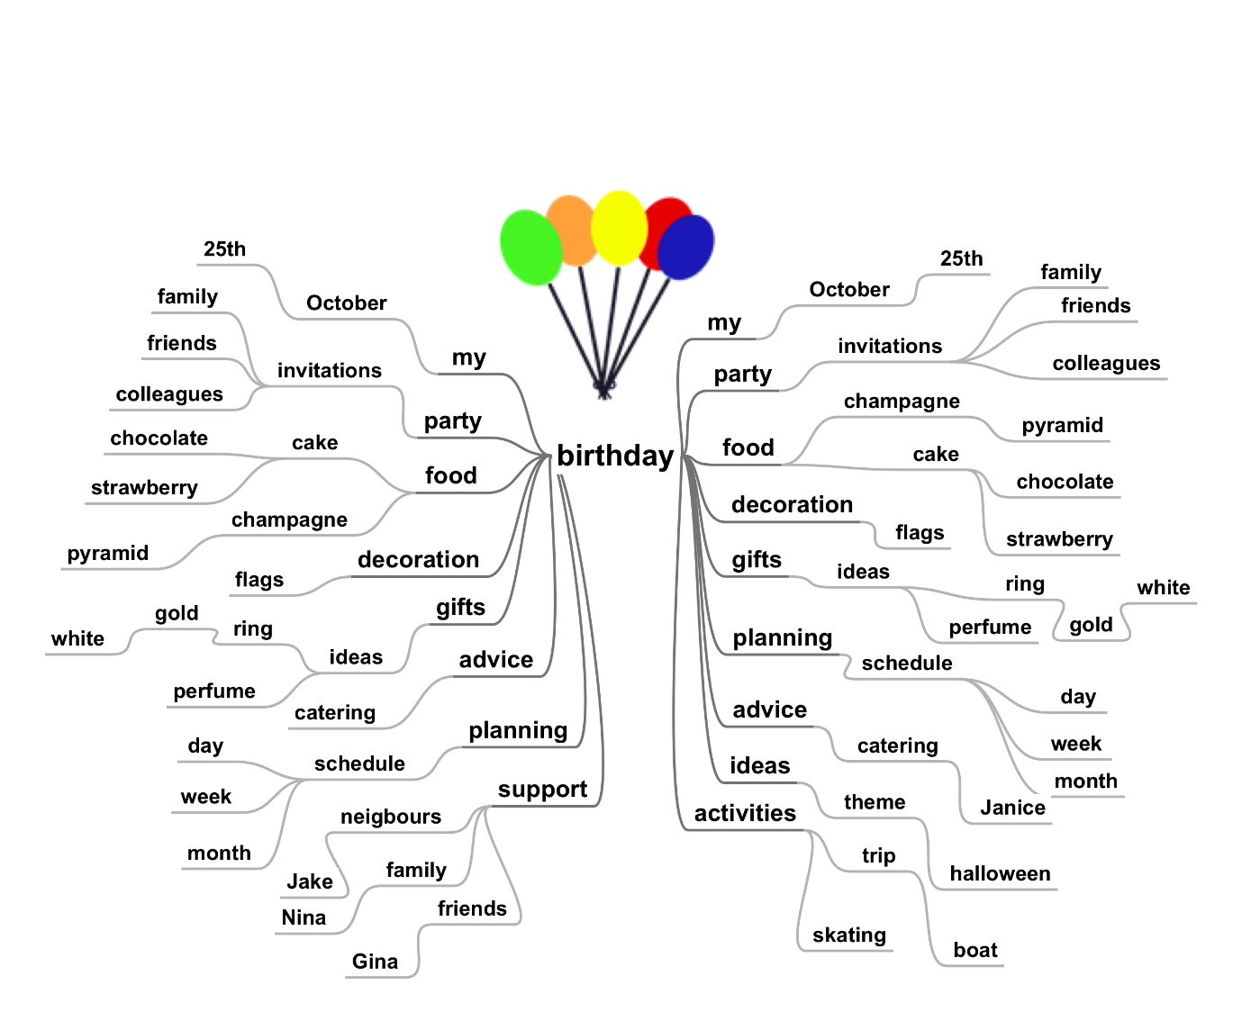

*Fig. 9 Too many associations create chaos*

* 1. **Color& images**

The use of color is important in the mind map. Research shows that people who use color and images in their imagination, when they are learning, are better in remembering than those who don’t.

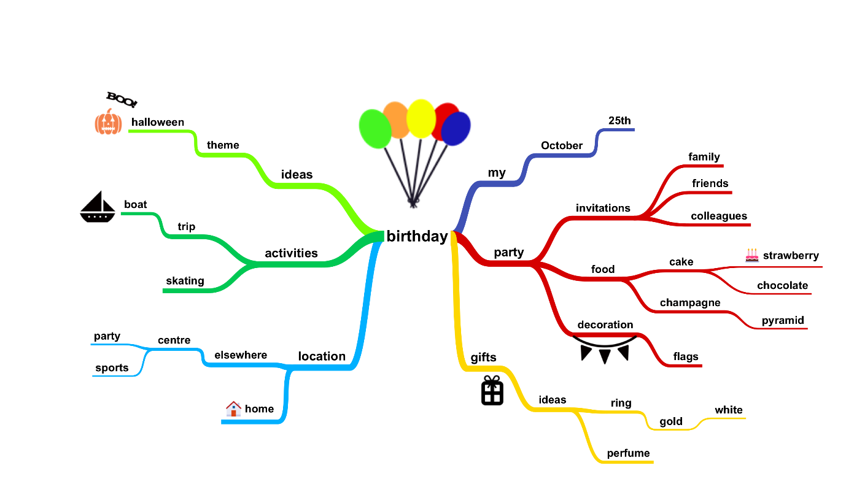

*Fig.10 In the mind map images are used like keywords. The key image is a picture; a picture is worth a thousand words!*

### **Concept map**

A [concept map](https://miro.com/templates/concept-map-maker/) is a diagram that shows the relationships between different ideas. This helps you understand how they’re connected.

Every concept map — whether it’s simple or complex — is made up of two key elements:

* **CONCEPTS:** These are typically represented by circles, ovals, or boxes and are called “nodes.”
* **RELATIONSHIPS:** These are represented by arrows that connect the concepts, and the arrows often include a connecting word or verb (but they don’t have to). These arrows are called “cross-links.”

The easiest way to understand a concept map is by looking at one, so let’s take a peek at a super simple example:

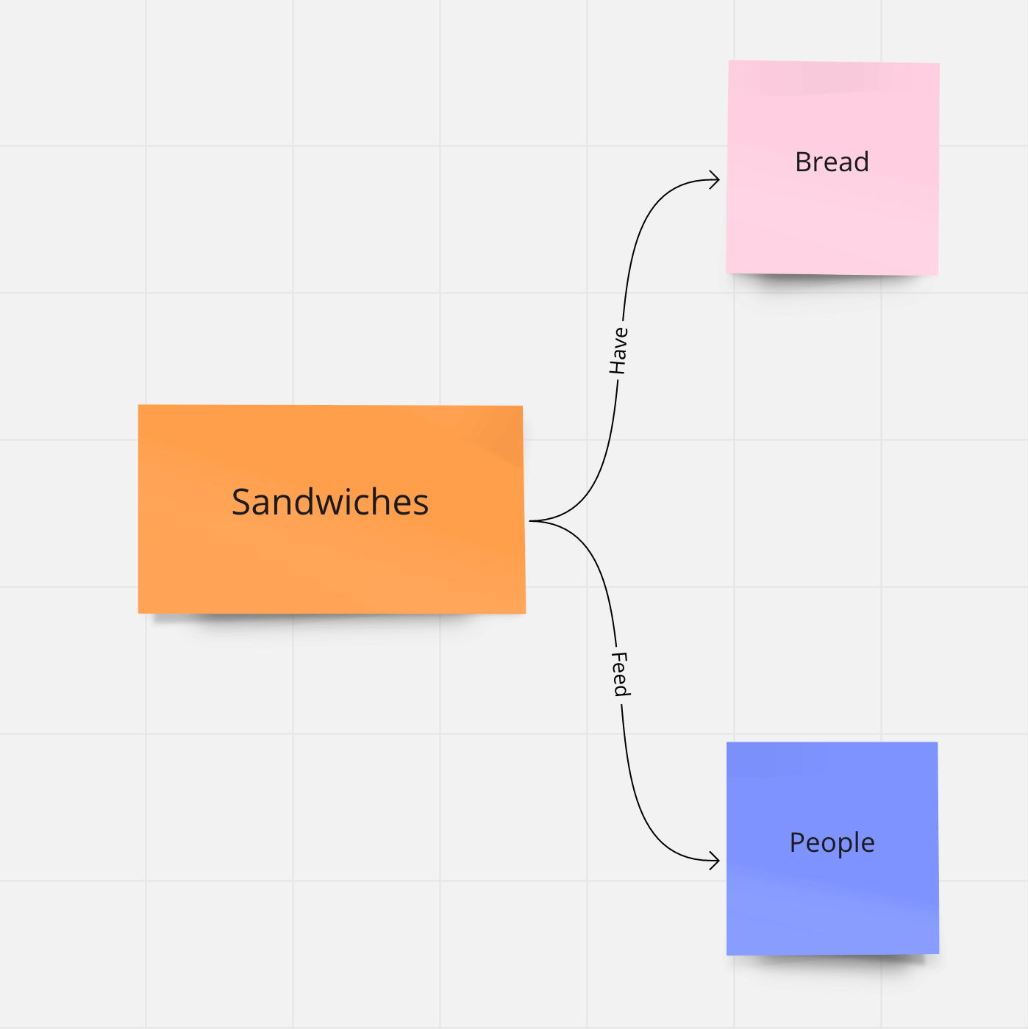

A simple example of a concept map

That’s only the start, and you’d continue to build on that concept map by adding more ideas and drawing connections between them. Eventually, your concept map could turn into a web of plenty more sticky notes and arrows.

**4.1. Concept map definition**

Looking for a quick definition? A concept map is a visual tool or diagram that illustrates the relationships between different ideas so you can better understand their connections.

**4.2. What is the purpose of a concept map?**

Why go through the trouble of drawing all of these boxes and arrows? Well, because a concept map can help you do a number of different things, including:

* **DIG INTO A TOPIC IN DETAIL:** When creating a concept map, you start with an overall concept and then work to identify sub-topics. That requires that you and your team really sink your teeth into the subject, rather than grasping the surface-level information.
* **ORGANIZE YOUR THOUGHTS:** If you and your team participate in a brainstorming session or workshop, you’re bound to end up with a ton of ideas. That big jumble can be difficult to act on, and a concept map helps you make sense of them in a visual, easy-to-understand way.
* **REMEMBER IMPORTANT INFORMATION:** Studies show that [visual learning](https://scholar.utc.edu/cgi/viewcontent.cgi?article=1171&context=mps#:~:text=Overall%2C%20our%20study%20found%20that,better%20recall%20than%20auditory%20learning.) produces better recall than auditory learning. So, if you and your team need to work through a problem or understand a topic, a concept map will boost both comprehension and retention.
* **UNDERSTAND RELATIONSHIPS:** The emphasis on relationships is the biggest benefit of a concept map, as it exists to not only show you ideas but how they relate to one another. This can help you and your team uncover connections that you wouldn’t have identified on your own.

See? A concept map is more than just bubbles and lines. It’s a powerful tool that can help you understand the ins and outs of the topic at hand.

* 1. **Types of concept mapping (and when to use them)**

The nuts and bolts of concept maps remain the same — there are concepts and connectors. But, these maps can be set up in a variety of different ways. Let’s look at the four most common types of concept maps and when you might want to use each one.

**a. Spider map**

This map gets its name because it looks a lot like a spider web. You’ll start with your core idea at the center, and then branch outwards to subtopics in a radial pattern. Your subtopics can branch out into smaller subtopics, and so on and so forth.

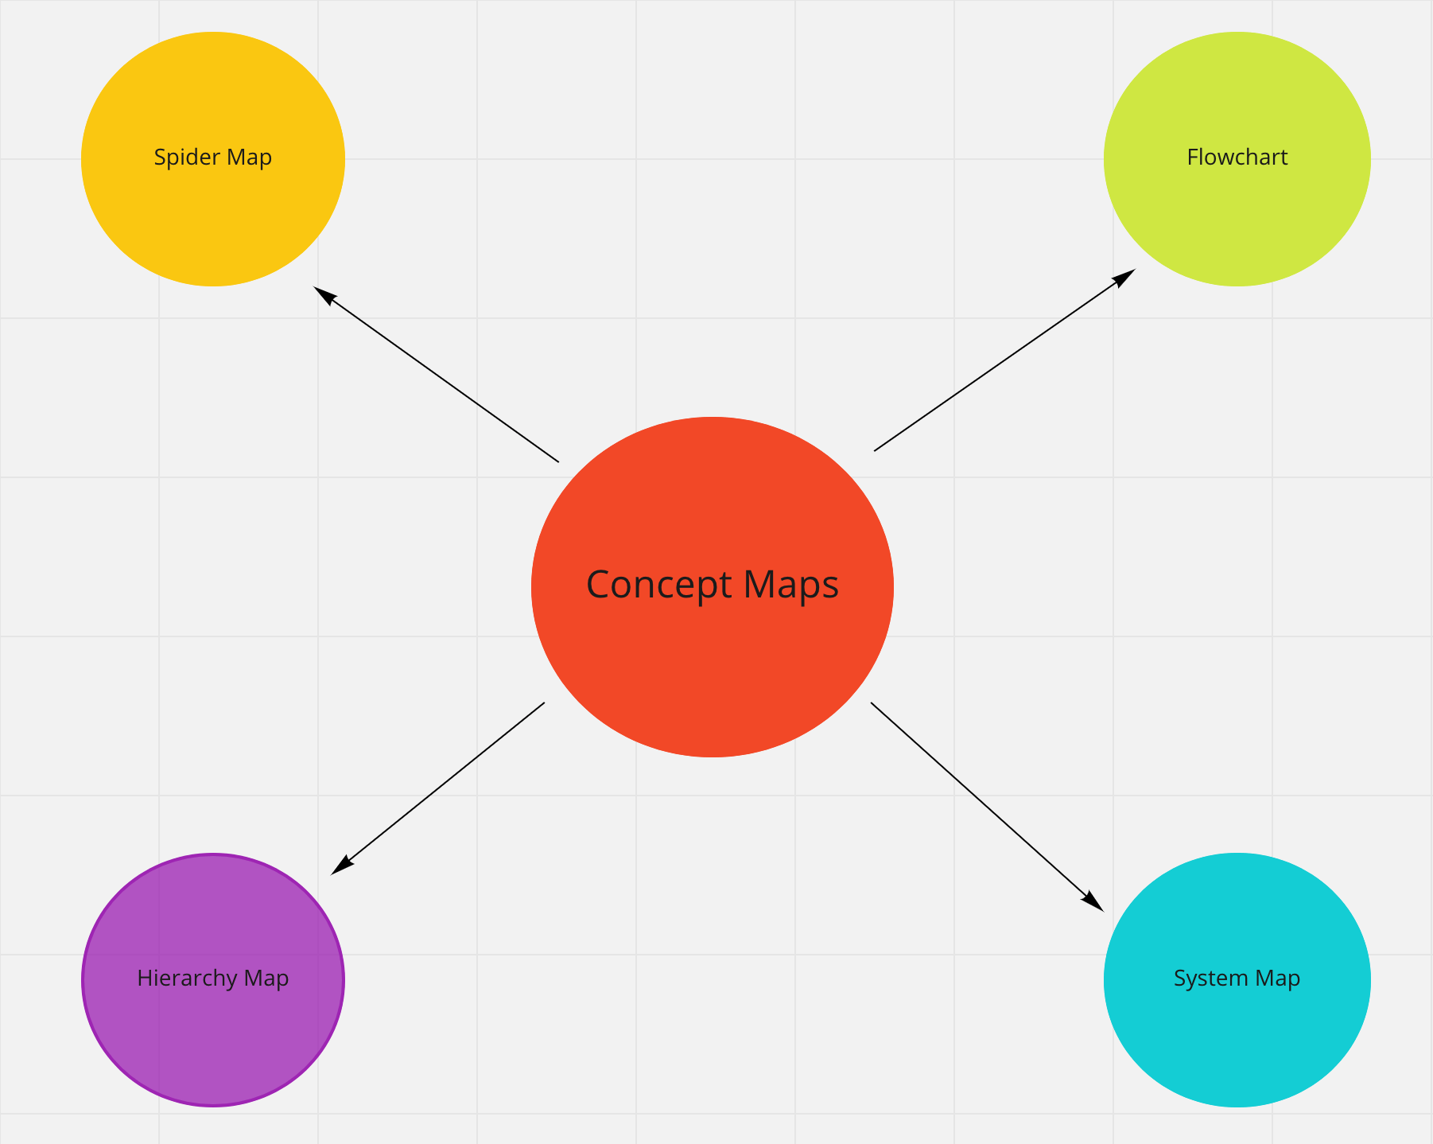

An example of a spider map

WHEN TO USE IT: When you have a single idea or theme that you want to build upon.

**b. Flowchart**

You’ve probably seen a [flowchart](https://miro.com/templates/flowchart/) before, but you might not have known that it was actually a type of concept map. This concept map shows the steps of a process. Typically, the arrows represent different choices that are made or actions that are taken — almost like you’re choosing your own adventure.

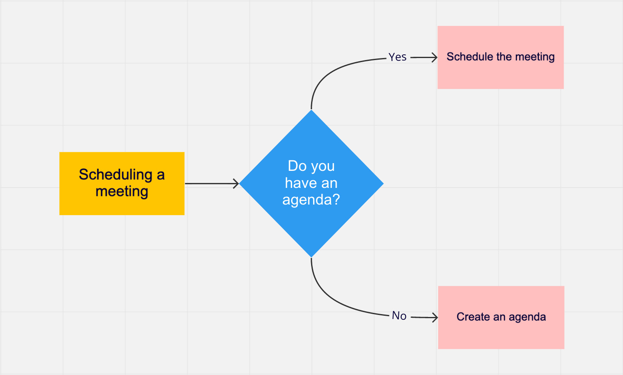

A flowchart is also a type of concept map

WHEN TO USE IT: When you need to understand a process or make a decision.

**c. Hierarchy map**

A hierarchy map is a type of concept map that shows the order of something. For example, think about your company’s organizational chart. That’s an example of a hierarchy map, as it shows people’s roles and their levels of superiority.

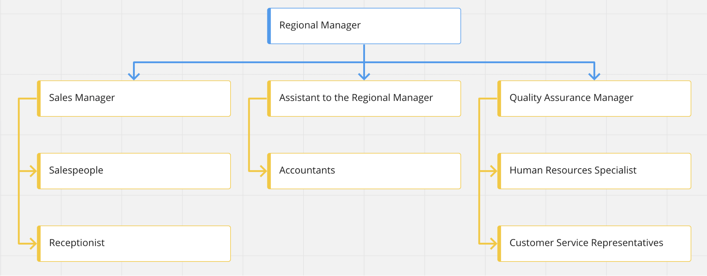

A hierarchy map is a type of concept map that shows structure and order

WHEN TO USE IT: When you need to understand the elements of a system, along with which elements are in the highest position and which are in the lowest.

**d. System map**

A system map is undoubtedly the most complex of all of the types of concept maps, as it shows all of the different parts of a concept and how they’re interrelated. Connecting lines can include a “+” or a “-” to note positive or negative correlations. They often end up looking like webs, but they don’t necessarily need to move outward from the center the way a spider map does.

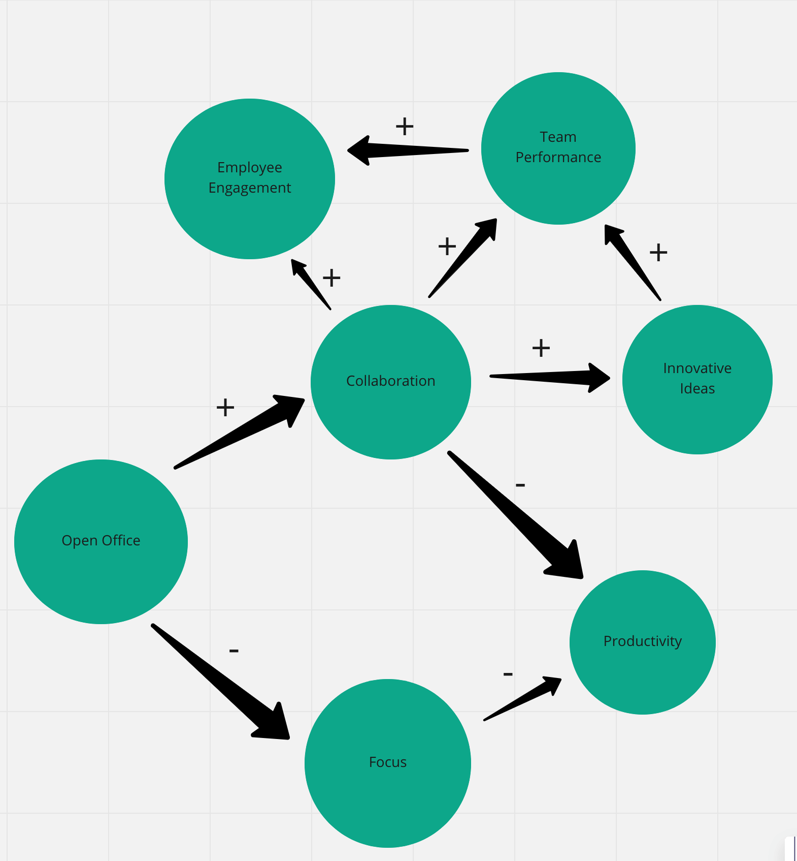

The most complex of all the concept map types, the system map

WHEN TO USE IT: When you need to understand the inner workings of how a system or team is functioning.

**4.4 Summary**

A concept map is a visual tool that helps you dig into an idea in detail. This diagram pushes you to explore subtopics, understand relationships, and organize your thoughts in a logical and systematic way.

1. **What Is the Product Life Cycle?**

PLC is an assumption that every product goes through that involves the same pattern of introduction into the market, growth, maturity, and decline. As the product spends more time in the market and it makes its way through the cycle, its sales increase. Each product’s PLC is different in the length of scope and duration, and each product is at risk of not making it out of the introduction phase. However, the company strategy should remain consistent throughout each of the phases.

The PLC, in brief, is as follows:

**Stage 1:** Product Development: The new product is introduced; this is when all of the research and development happens.

**Stage 2:**Product Growth: The product is more than an idea or a prototype. At this stage, the product is manufactured, marketed, and released. Distribution increases, demand increases, and competition also increases.

**Stage 3:** Product Maturity: During this stage, the product is widely available, and there are many competitors in the marketplace. You market the product to different segments, but more spending on advertising will have no impact on its demand.

**Stage 4:** Product Decline: The product is losing market share, or becoming obsolete. It is well past its point of highest demand, and the demand decreases.

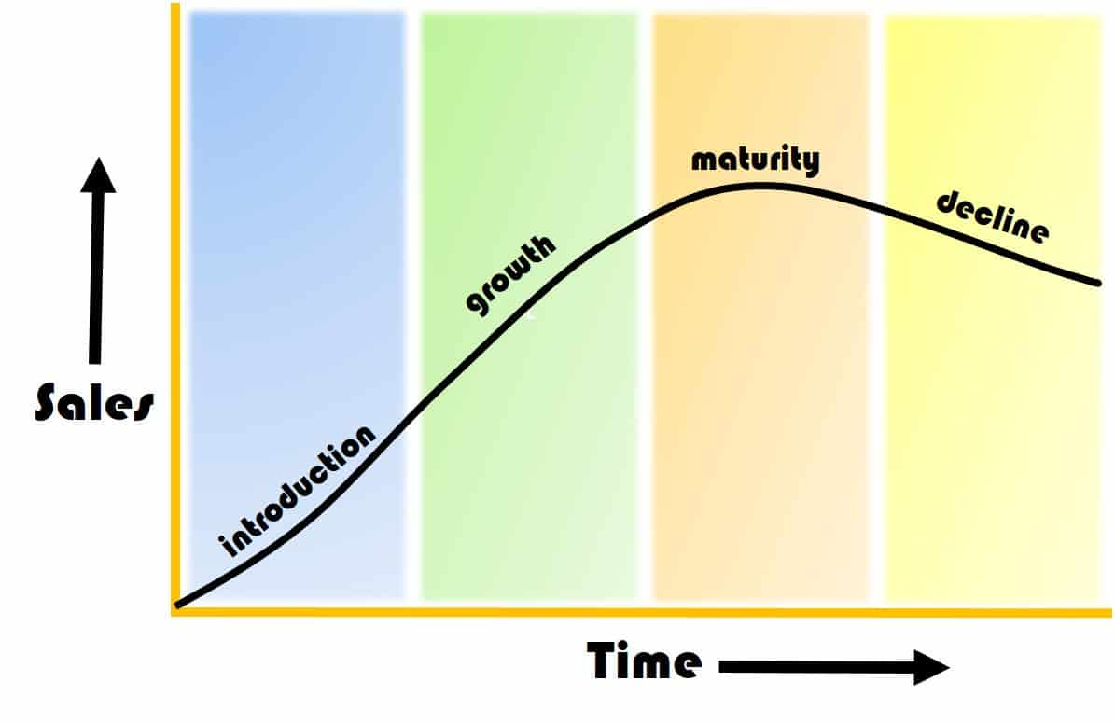

Additionally, the product life cycle affects the average selling price (ASP). The ASP is how much you generally sell your products or services for. When a product has many competitors or it is in the decline stage of its PLC, the ASP will be lower.

Product image also drives the ASP. Products with an image of exclusivity have a higher ASP. For example, Louis Vuitton luggage is considered a luxury brand of products that are made by hand and use the finest materials. There is a limited assortment of products, a long wait time to procure one, and a higher than average price point. The company has even sped up their manufacturing process, but the price point still reflects the exclusivity and time to market of a custom bag. In fact, Louis Vuitton increased its prices in 2013 to attract more high-end consumers because they experienced a decline. This approach is an interesting twist on the PLC since normally the prices would drop with the waning in demand.

* 1. **Linear and Closed-Loop Manufacturing Cycle**

So far, we have been discussing the typical PLC. It is linear and at each stage has material, labor, and resource inputs. It also has waste outputs that can negatively affect the environment. Researchers assert that the introduction stage where design takes place determines between 70 percent and 90 percent of the life cycle costs. At this stage, manufacturers can also remove excess waste and continue to develop sustainable manufacturing practices. These practices should include products being reused, recycled, and remanufactured. With this, you are developing a closed-loop manufacturing cycle. Instead of a linear PLC, this represents a circular PLC.

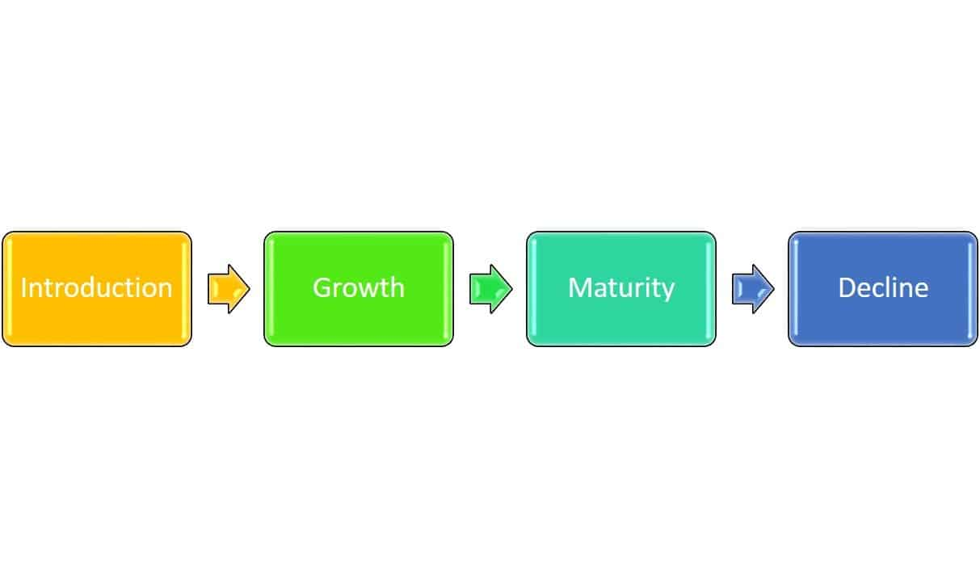

Linear Product Life Cycle

A closed-loop cycle is a natural extension of PLM, and creates a truly full life cycle that takes your obsolete or used products back into raw materials, not just assigning them to waste. Although many of these closed-loop products are down cycled (converted into lesser-quality materials), the products are still recycled and reused repeatedly.

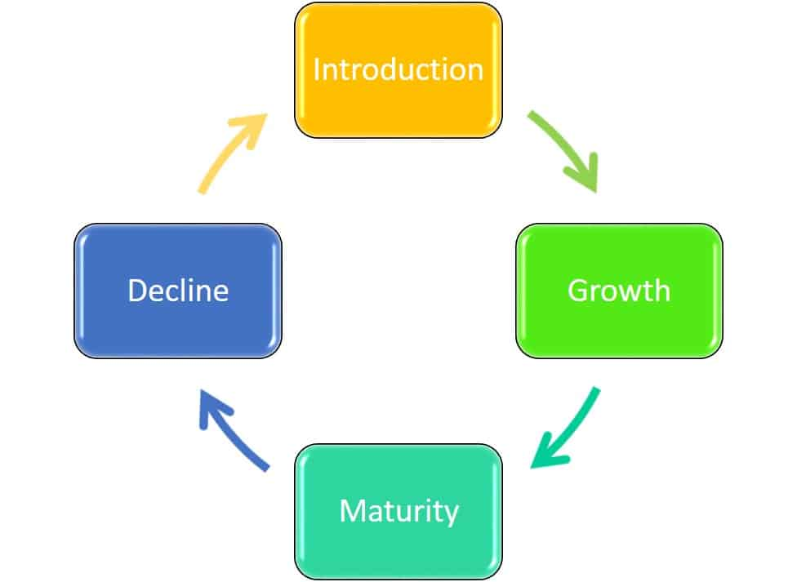

Closed Product Life Cycle

An example of this is Dell’s take-back program, which takes the computers that it manufacturers and turns a majority of them into new computers. Other companies separate out product components and sell them to their partners on the commodities market, as raw materials, who then make them into new products. The benefits of a closed-loop system include:

* Better for the environment
* Does not affect performance or price
* Fewer carbon emissions in manufacturing
* As programs scale, they become cheaper and more effective

1. **Commodities:**

Commodities are an important aspect of most American's daily life. A commodity is a basic good used in commerce that is interchangeable with other goods of the same type. Traditional examples of commodities include grains, gold, beef, oil, and natural gas.

For investors, commodities can be an important way to diversify their portfolios beyond traditional securities. Because the prices of commodities tend to move in opposition to stocks, some investors also rely on commodities during periods of market volatility.

In the past, commodities trading required significant amounts of time, money, and expertise, and was primarily limited to professional traders. Today, there are more options for participating in the commodity markets.

* Commodities that are traded are typically sorted into four categories broad categories: metal, energy, livestock and meat, and agricultural.
* For investors, commodities can be an important way to diversify their portfolios beyond traditional securities.
* In the most basic sense, commodities are known to be risky investment propositions because their market (supply and demand) is impacted by uncertainties that are difficult or impossible to predict, such as unusual weather patterns, epidemics, and disasters both natural and human-made.
* There are a number of ways to invest in commodities, such as futures contracts, options, and exchange traded funds (ETFs).

1. **Infrastructure**

Infrastructure is the set of facilities and systems that serve a country, city, or other area, and encompasses the services and facilities necessary for its economy, households and firms to function. Infrastructure is composed of public and private physical structures such as roads, railways, bridges, tunnels, water supply, sewers, electrical grids, and telecommunications (including Internet connectivity and broadband access). In general, infrastructure has been defined as "the physical components of interrelated systems providing commodities and services essential to enable, sustain, or enhance societal living conditions" and maintain the surrounding environment.

1. **Service**

A service is an "(intangible) act or use for which a consumer, firm, or government is willing to pay." Examples include work done by barbers, doctors, lawyers, mechanics, banks, insurance companies, and so on. Public services are those that society (nation state, fiscal union or region) as a whole pays for. Using resources, skill, ingenuity, and experience, service providers benefit service consumers. Services may be defined as intangible acts or performances whereby the service provider provides value to the customer.